<Logo of the Company/Group might be here.>

<Company/Group number>

<Project Name>
Software Design Specification (SDS)
Version: <X.Y>
CM Identifier: <Configuration Management Identifier that can be used to uniquely reference the document among other documents and you should rename the file name with this identifier >

<The Software Design Specification (SDS) sections given in this outline are guidelines to the contents of your SDS. Include at least these sections. Your team may have good reasons for wanting to deviate from this proposed outline. In this case, you must motivate any deviations to me. If a section is not applicable in your case, do not delete it; instead, give the topic heading and write "Not applicable".
You will note that there is some overlap in the contents from document to document. This redundancy allows each document to stand on its own. >

Revision History

Sl. No. | Prepared/  Modified by | E-mail | Version | Date | Approved by | Descriptions/  Remarks
1. | <Name(s) of the author(s)> | <e-mail> | <x.y> | <Mmm. dd, yyyy> | <Name of the approving authority> | <The action performed on the document. Include a link to the modified part>

Distribution list
Name | E-mail | Notes
<List all persons/departments to which this document will be distributed> |  | <Any useful remarks like “reply needed”, “for approval”, etc…>

Table of Contents

1. Introduction 5
1.1 Purpose of this Document 5
1.2 Scope 5
1.3 Table of Acronyms and Definitions 5
1.3.1 Definition 5
1.4 References 5
1.5 Overview of Document 6
2. System Architecture 6
3. Design Models 6
3.1 Design Patterns Description 7
3.1.1 Design Pattern I 7
3.1.2 Design Pattern II 7
3.2 Class Diagrams 7
3.3 Sequence Diagrams 7
3.4 State Chart Diagrams (if needed) 7
3.5 Activity Diagrams (if needed) 7
3.6 Component Diagrams (if needed) 7
4. Data Models 7
5. System Deployment 7
6. Traceability to Requirements 7

List of Tables

List of Figures

Introduction

Purpose of this Document

This document will define the design of Study Buddy website and how its supposed to have all its functionalities carried on, but the exact details of how the functions work won’t be described out in this document. It also contains specific information about the expected inputs and outputs of the application and the class that will be used and their interaction with each other to reach the needed requirements, all this is outlined in detail at the end of this document

Scope

The purpose of the project is to create a centralized database system, and modules that will help the user look for the needed books and/or tools with ease, also to donate any book/tool the user wishes to give up for free through a website using their computers or mobile phones.
This document provides the architecture and design of Release 2.0 of the Study Buddy website. And it will show how the design will accomplish the functional and non-functional requirements detailed in the Software Requirements Specification (SRS) document.

Table of Acronyms and Definitions

Term | Definition
Engineering Student | A person who will access the web page and use it to perform the trade he wishes, whether it be borrowing, lending, requesting a book or engineering tool.
Software design specification | Also known as SDS document, is a document that contains the description of a software product, that a software designer writes in order to give a software development team overall guidance to the architecture of the software project.
Stakeholder | Any person with an interest in the project and is affected by it who is not a developer.
Database | Collection of information that are of use inside the system (E.g. book names, students information…).
Teaching Assistant | A person who is not a student but has the right to look for a book if needed in certain post graduate studies or to prepare for giving a tutorial.
Engineering Tools | Tools that used by engineers (E.g. T-Ruler, compass, eraser shield, drawing board, triangular rulers).
Professors | A member of the teaching staff who can use this software to either help the students and guide them by giving them books, or can use it to borrow books for reasons similar to those of the Teaching Assistants’.
User | Student, Teaching Assistant, or Professor.  People who potentially use the software to gain benefit from it.
Entity-Relationship diagram | Also known as E-R diagram, is used to describe all the entities pointing out their attributes (Properties) and how they interact with each other
Communication diagrams | Such as the UML diagram (Unified modelling language), are a collection of diagrams used to visualize a software program, showing the interactions between objects in sequence, describing both the static and dynamic behavior of the system
Entity | A representation of a real object in the system of software, so that we can model it and perform operations on/with it.
Attributes | Properties of the entities, i.e. what defines them and makes them different from each other.
Cart | A virtual holder for the books or tools so that we can perform a certain transaction on them.
Relationship | Its meaning here is the interaction between entities and it’s properties.
Cardinality of a relationship | I.e. one to one, Many to one. The number of possible entities on one side that can interact with another possible number of entities on the other side of a relationship. E.g. one user can donate more than one book so the cardinality of this relationship is one user to many books, one to many.
Unique attribute | An attribute that is not repeated in any two entities (Like a username).
Donation | When a user decides to give his book/tool for a period of time so that other users can borrow it.
Rate | When the user decides to rate other users so that everyone can be aware of them and how they behave

References

[1] “Software Engineering”, 9th Edition, Ian Somerville, Pearson, 2011
https://edisciplinas.usp.br/pluginfile.php/2150022/mod_resource/content/1/1429431793.203Software%20Engineering%20by%20Somerville.pdf .

Overview of Document

The second part of the SDS document will describe the architecture of the system and what are the components of the system, this will be described using various diagrams and structural models to show the relationships between users and system objects.
The third section of the document will talk about data objects in the system and how they are controlled and their relationships with each other, in brief it will explain the dynamics of the system and how to it can be manipulated.
The fourth section of the document will show the data models and how they are diagramed with all their attributes.
The fifth section will talk about the deployment of the system and how it will work using various diagrams and models. Also it will discuss the runtime and execution of the system, and how the components worked out.
The sixth and last section will trace the requirements to design elements to show which requirements were met, and which will be finished later on in the next versions.

System Architecture
<The first phase of the software architectural design is concerned with decomposing the system into a set of interacting subsystems. Use one or more UML class diagrams to represent the system architecture. Each subsystem should be represented by a UML package symbol stereotyped as <<subsystem>>. Communications and dependencies between subsystems should be represented by dependencies relationships between packages [2].
Select the structural model that best describes your system here (e.g. the repository model, the layered model, etc). Refer to [1] for the discussion of these standard models>

Figure 1 – System Architecture

<To work as a system, subsystems must be controlled so that their services are delivered to the right place at the right time. Control models are concerned with the control flow between subsystems. Refer to [1] for the discussion of control models. You should describe in one or two statements how the subsystems are controlled (e.g., centralized control, event-based control)>

Design Models
<This should contains class, interaction, activity and state chart diagrams that models your system. Diagrams may contain classes from different subsystem/layers. Remember that your design should be complete and no ambiguities should appear. Developers will have to translate these diagrams into code. Assign each design element (class, sequence) an ID that can be used in the traceability matrix>

Design Patterns Description
<You should illustrate which Design Patterns you've used, where and why? You've to use at least 2 Design Patterns>

Design Pattern I

Design Pattern II

Class Diagrams
<You should use one or more class diagram to model the relationships between the classes of the system. Each class diagram may contain classes from different layers.>

Sequence Diagrams
<For each service provided by the system, you should use sequence diagrams to model the interaction between objects to realize this service. Each sequence diagram may contain classes from different layers.>

State Chart Diagrams (if needed)
<You may use state chart diagrams to model how individual objects change their state in response to events or to model how the subsystem changes its sates.>

Activity Diagrams (if needed)
<You may use activity diagrams to model the work flow inside the subsystem or to model a specific operation/algorithm.>

Component Diagrams (if needed)
<You should use component diagrams to model the organization and dependencies among the source files of this system>

Data Models

The following E-R diagram will show the various classes we have along with their attributes and they interact with each other.

N.B: The first attribute to be mentioned in each entity is the entities primary attribute.
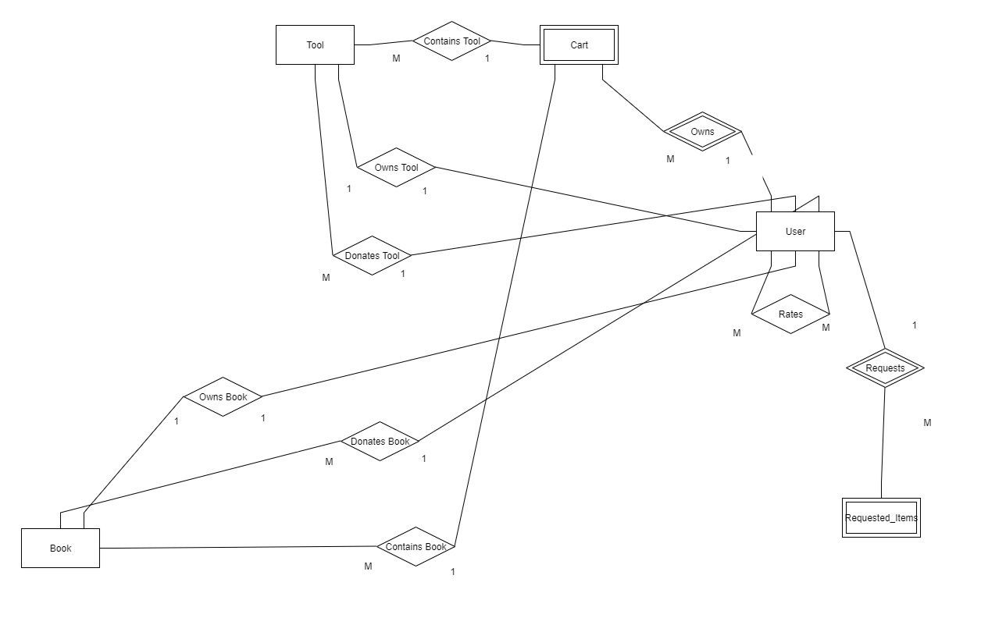
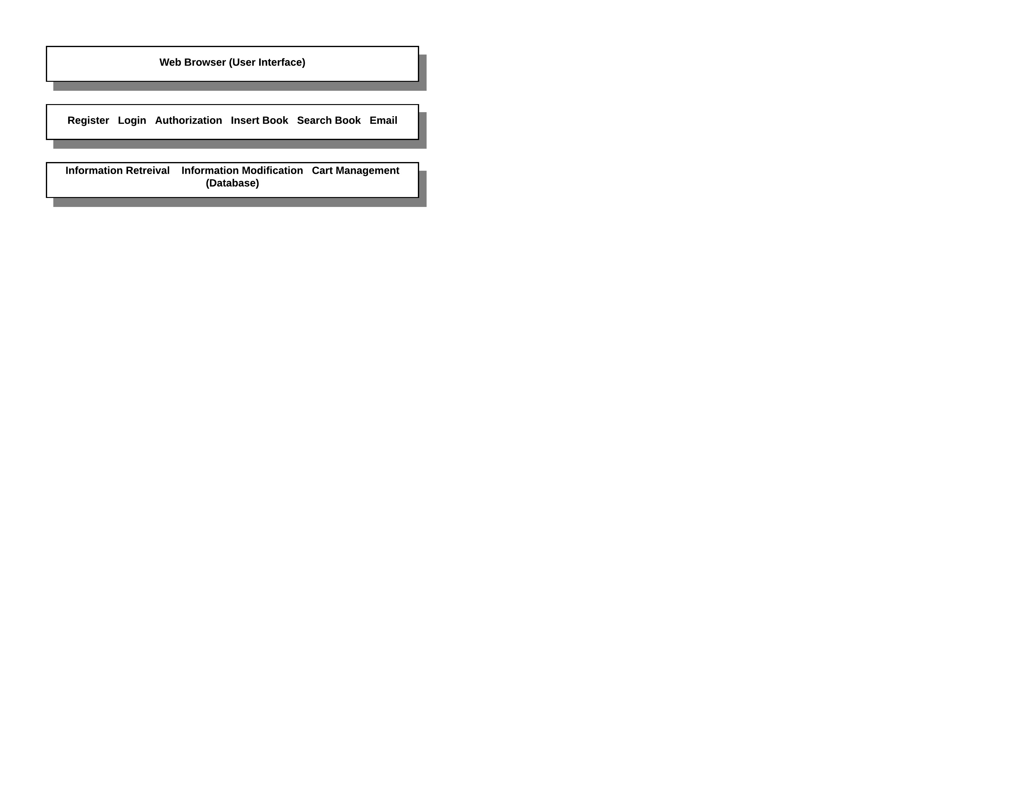
Figure 1 - Entity-Relationship Diagram (ERD)

Classes and their attributes:

1-Book:

Books are one of the main entities as they are the objects which the students will trade with each other. Such entities have various attributes that describe their uniqueness, status and to which students they will suit the most.

Attributes:
- Book_ID: A unique identifier for each book.
- Book_Status: Describes whether the book is currently with someone or with its owner.
- Code: MTH, CMP, ELC, CHM… etc.
- Edition: Edition Number of the book.
- Author: Books Author name.
- Title: Title of the book.
- Book_Duration: Duration of donation.
- Book_Owning_Duration: Duartion of borrowing the book.

2-Tool:

Tools are also from the main entities since many first-year students will need to borrow them from other students who won’t need them. Therefore, we need to store the data regarding their uniqueness, status, and other attributes that describes the tool.

Attributes:
- Tool_ID: A unique identifier for each book.
- Tool_Status: Describes whether the tool is currently with someone or with its owner.
- Type: Whether it’s a T-ruler, compass, triangle ruler… etc.
- Manufacturer: Samir & Ali, Alwan, Rotring… etc.
- Tool_Duration: Duration of donation.
- Tool_Owning_Duration: Duration of borrowing the tool.

3-User:

The user is always considered an important entity since we need to store data of the students who login to the website and donate/borrow the tools, so that we can facilitate their exchange processes without any inconveniences or delays.

Attributes:
- User_ID: Unique identifier for each user, will be used by the user to login to the website.
- Password: Passcode used by the user to complete his/her login to the website.
- Email: The electronic-mail the user will use to sign up on the site, it might be used to remember his password or change it.
- Phone: The number of the cellular phone that is used by the user.
- Year: Sophomore, Junior-1, Senior-2… etc.
- Department: CCE, EEE, CEM… etc.
- Join_Date: The date which the user signed up.
- Rating: The rate that the user gets from other users according to his behavior with the tools/books he borrowed.

4-Cart:

The cart is the object that holds the item that a certain student wishes to borrow. In other words, it’s the gateway for the transaction between the students.

Attributes:
- Cart_ID: Unique identifier for the cart.
- Create_Date: The date which the cart was made.

5-Requested_Items:

Requested items are the items that a user can specifically request if he fails to find that the items are up for donation. E.g. if a student can’t find a specific math book for linear algebra he can specially request it so that any other student can see that request. Therefore, we are allowing to ask for help and ease it’s delivery.

Attributes:
- Request_No: Unique number that identifies each request.
- Request_Date: The date which the request was made by the user.

Relationships between classes and their attributes (if any existed):

1-Contains_Book:

Relationship between Book and Cart (Many to one). Shows that a cart may contain books inside it.

Attributes:
None.

2-Contains_Tool:

Relationship between Tool and Cart (Many to one). Shows that a cart may contain books inside it.

Attributes:
None.

3-Owns:

Identifying relationship between User and Cart (User identifies the cart, and the relation is one to many). Shows that a user can create a cart and control it and the items inside.

Attributes:
None.

4-Requests:

Identifying relationship between User and Requested_Items (User identifies Requested_Items, and the relation is one to many). Shows that a user can make special requests to find an item of desire, whether it was a book or tool.

Attributes:
None.

5-Donates_Book:

Relationship between Book and User (Many to one). Shows that a user can donate a book so that it can be added to the database.

Attributes:
Book_Duration: Describes the duration the book is up for donation.

6-Owns_Book:

Relationship between Book and User (One to one). Shows that a user can borrow a book for a certain period of time.

Attributes:
Book_Owning_Duration: The duration which the user is allowed to have the book for himself.

7-Donates_Tool:

Relationship between Tool and User (Many to one). Shows that a user can donate a tool so that it can be added to the database.

Attributes:
Tool_Duration: The duration a tool is up for donation.

8-Owns_Tool:

Relationship between Tool and user (One to one). Shows that a user can borrow a tool for a certain period of time.

Attributes:
Tool_Owning_Duration: The duration which the user is allowed to have the tool for himself.

9-Rate:

Relationship between user and user (One to one). Shows that a user can rate another user to show his opinion regarding the rated user.

Attributes: None.

System Deployment
<You should use component and deployment diagrams to model how the system will be deployed. First, use component diagrams to model the organization and dependencies among the system executable components. Second, use deployment diagrams to model the configuration of run time processing nodes and the components that live on them>

Traceability to Requirements
<This should maintain a matrix similar to the Traceability Matrix in the Software Requirements Specification document. The purpose of this matrix is to map requirements to design elements. This will immediately point out requirements that have not been considered. It will also allow you to trace into the design elements that require to be changed if requirements change. Use requirement IDs as row headers and design element IDs as column headers>

